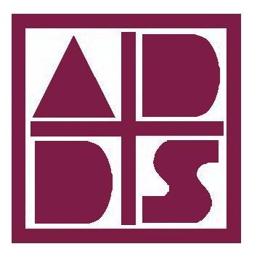

Who we are
The Iowa Department of Public Health licenses the Alcohol and Drug Dependency Services of Southeast Iowa (ADDS) to provide prevention, substance use disorder and problem gambling treatment services. Individuals and family members who experience the effects of alcohol and drug use disorder may receive ADDS treatment services as well as those persons suffering from compulsive gambling.
Substance use disorders are challenges like any other illness – you are not alone! We have trained professionals to help you on this journey to recovery.
 |  |  | Peer Recovery Coaching
Contact Us  You can expect to be greeted by a helpful staff member at all offices. We will treat you with dignity and respect. Your treatment services will be confidential and held to the highest professional standards.  1340 Mt. Pleasant St. | Burlington, IA 52601 | Phone: 319-753-6567  122 N. Main St. | Mt. Pleasant, IA 52641 | Phone: 319-385-2216  928 Main St.| Keokuk, IA 52632 | Phone: 319-524-4397  304 Hwy 61 North | Wapello, IA 52653 | 319-523-8436  Email:: information@addsiowa.org  Web: www.addsiowa.org | Forms: www.addsiowa.org/patient-forms |  |  | Alcohol and Drug Dependency Services

Do you need help with any of these tasks?  - Writing a Resume - Finding childcare  - Finding a job - Obtaining a gym membership  - Getting a bus pass - Acquiring food and clothing  - Managing your DHS case - Finding a church or spiritual gathering  - Setting goals - Budgeting  - Sober activities - Self-care  - Motivation - Accountability  - Parenting  - Renting an apartment  PEER RECOVERY COACHING  can assist you with these tasks and more. |  |  | Available to all ADDS Clients!
 |  |  | Here to Help
 |  |  | 1 | Peer recovery coaches can help you create a life you no longer want to escape from. We focus on health, home, purpose, and community in individualized work with you.
 |  |  | On Your Team
 |  |  | 2 | It’s always a good idea to have another person on your team. Recovery coaching is for clients looking for a mentor, motivator, accountability partner, or someone who can closely relate to their experiences with addiction.
 |  |  | We Understand
 |  |  | 3 | Peer Recovery Coaches use the life experience of recovery, combined with training, to assist others in starting and maintaining sobriety.
 |  |  | 2

